Blockchain Viva
NAME: Ved V Joshi
DIV: D20A
ROLL NO: 46

M2 Q26. Multi-signature Bitcoin transaction mechanism (10 marks)
Question: Design a Bitcoin transaction mechanism using multi-signature addresses that requires approval from multiple authorized users before funds can be spent. Explain its advantages. (10 Marks)
Answer:
A multi-signature (multisig) address locks bitcoin behind an m-of-n rule: the coins move only when m valid signatures from n registered public keys are attached to the spending transaction, so no single person can spend alone.

1. Concept
A multisig address is an ordinary-looking Bitcoin address whose locking script commits to a set of n public keys and a threshold m. Common forms are 1-of-2 (joint account), 2-of-2 (both parties must agree), 2-of-3 (the most widely used) and 3-of-5 (a board of directors).

2. Design: a 2-of-3 company treasury wallet
Three authorised users control the wallet: Alice (CEO), Bob (CFO) and Carol (security officer). Policy: any two of the three must approve every payment.
Component | Design choice
Threshold | m = 2 approvals out of n = 3 keys
Keys | One private key per user, generated and kept on that user's own hardware wallet; never shared
Script type | P2WSH (native SegWit multisig), address starts with bc1q. The older P2SH form starts with 3
Key order | Public keys sorted lexicographically (BIP 67) so all three users derive the identical address
Signing workflow | A Partially Signed Bitcoin Transaction (PSBT, BIP 174) is passed from signer to signer

3. Step-by-step mechanism
- Generate keys. Each user creates a key pair on their own device. Only the public key (or extended public key) is shared; private keys never leave the device.
- Build the script. Combine the threshold, the three public keys and the CHECKMULTISIG opcode into one witness (redeem) script.
- Derive the address. Hash the script (SHA-256 for P2WSH, HASH160 for P2SH) and encode the hash as an address. Each user derives it independently and confirms the addresses match.
- Fund the wallet. Anyone sends BTC to the address. The output is locked to the script hash; the script itself stays hidden until the coins are spent.
- Propose a payment. Bob builds an unsigned transaction: input = the multisig output, outputs = the payee plus change back to the multisig address, plus the fee. It is saved as a PSBT.
- Review and sign. Each approver checks the payee, amount and fee on their own device and signs the transaction hash. Bob signs first, then Alice (any two of the three would do).
- Combine and finalise. With two signatures collected, the PSBT is finalised into a complete witness: an empty dummy item, SigA, SigB and the witness script.
- Broadcast and validate. Nodes hash the revealed script and compare it with the hash in the output. They then run the script: OP_CHECKMULTISIG verifies each signature against the public keys in order and needs at least 2 valid ones. Fewer than 2 valid signatures means the transaction is rejected.
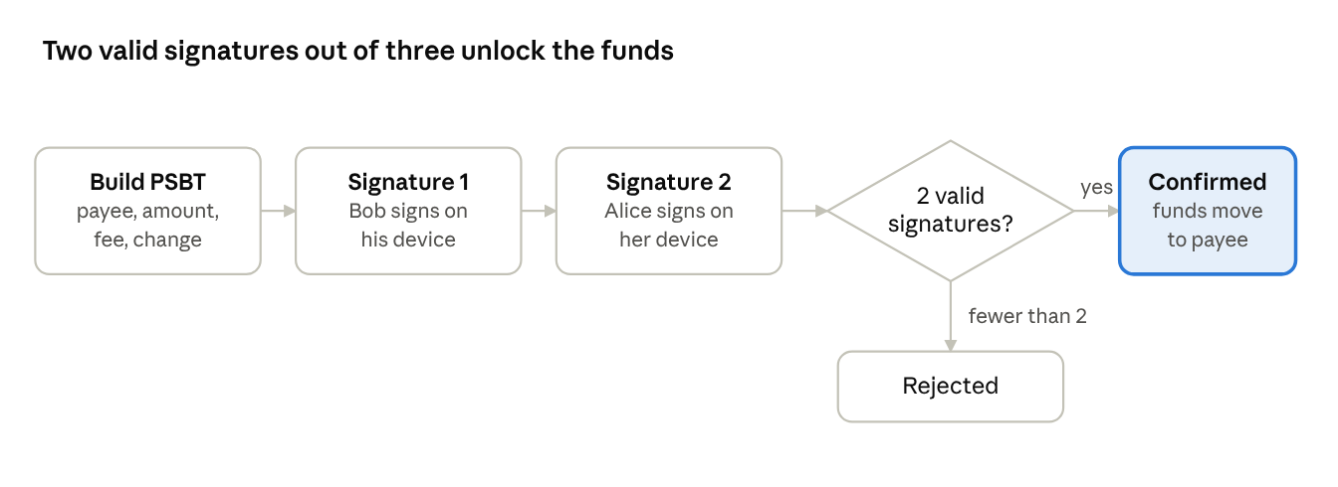
2-of-3 multisig spend · 4 steps, 1 check
Two of the three keyholders sign the PSBT; the third key is not needed. Nodes accept the spend only if at least two signatures verify.

4. Scripts involved
P2WSH (modern)
Locking script (scriptPubKey): OP_0 <SHA256(witnessScript)>
Witness script: OP_2 <PubKeyA> <PubKeyB> <PubKeyC> OP_3 OP_CHECKMULTISIG
Unlocking data (witness): <empty> <SigA> <SigB> <witnessScript>
P2SH (legacy)
Locking script (scriptPubKey): OP_HASH160 <HASH160(redeemScript)> OP_EQUAL
Unlocking script (scriptSig): OP_0 <SigA> <SigB> <redeemScript>
Three rules to remember:
- The leading empty item exists because of a historical off-by-one bug in OP_CHECKMULTISIG, which pops one extra stack item.
- Signatures must appear in the same order as their public keys in the script.
- Consensus allows up to 20 public keys in one CHECKMULTISIG; legacy P2SH is limited to about 15 by its 520-byte script size.

5. Advantages
Advantage | How multisig delivers it
No single point of failure | Stealing or compromising one key or device is not enough; an attacker needs m keys
Shared control, separation of duties | The maker-checker approval rule is enforced by the blockchain, not just by company policy
Resilience to key loss | In 2-of-3, one key can be lost or destroyed and the other two still recover the funds
Protection from insider fraud | One rogue employee or officer cannot move funds alone; collusion of m people is required
Trust-minimised escrow | Buyer, seller and arbiter hold a 2-of-3 wallet; the arbiter is needed only in a dispute and cannot take the funds alone
Security through diversity | Keys can sit on different devices, vendors and locations, so one malware infection or theft does not break the wallet
Native and third-party free | Built into Bitcoin Script; no smart-contract platform and no custodian is needed
Simple for senders | Payers just send to an address, exactly as with any other address
Transparent audit trail | Every spend is visible on chain, and a valid spend proves the required approvals existed
Backup and inheritance planning | One key can be held by a lawyer or in a safe-deposit box without giving that holder control

6. Limitations
- Transactions are larger than single-signature ones, so fees are higher.
- Signers must coordinate, which is slower than one person paying.
- The public keys (wallet descriptor) must be backed up as well as the private keys, or the address cannot be rebuilt.
- The full script is revealed when spending, which lowers privacy. Taproot with MuSig2 signature aggregation reduces this.

7. Conclusion
A 2-of-3 multisig wallet turns Bitcoin's single-owner model into a shared-approval model: funds are safe from a single compromised key, recoverable after a single lost key, and spendable only when the authorised users agree.

M6 Q13. Staking and governance tokens in network security and decision-making
Question: Apply the concepts of staking and governance tokens to illustrate how users participate in blockchain network security and decision-making.
Answer:
Users secure a proof-of-stake blockchain by locking tokens as collateral that can be destroyed (slashed) if they cheat, and they steer the protocol by voting with governance tokens; both give token holders real skin in the game.
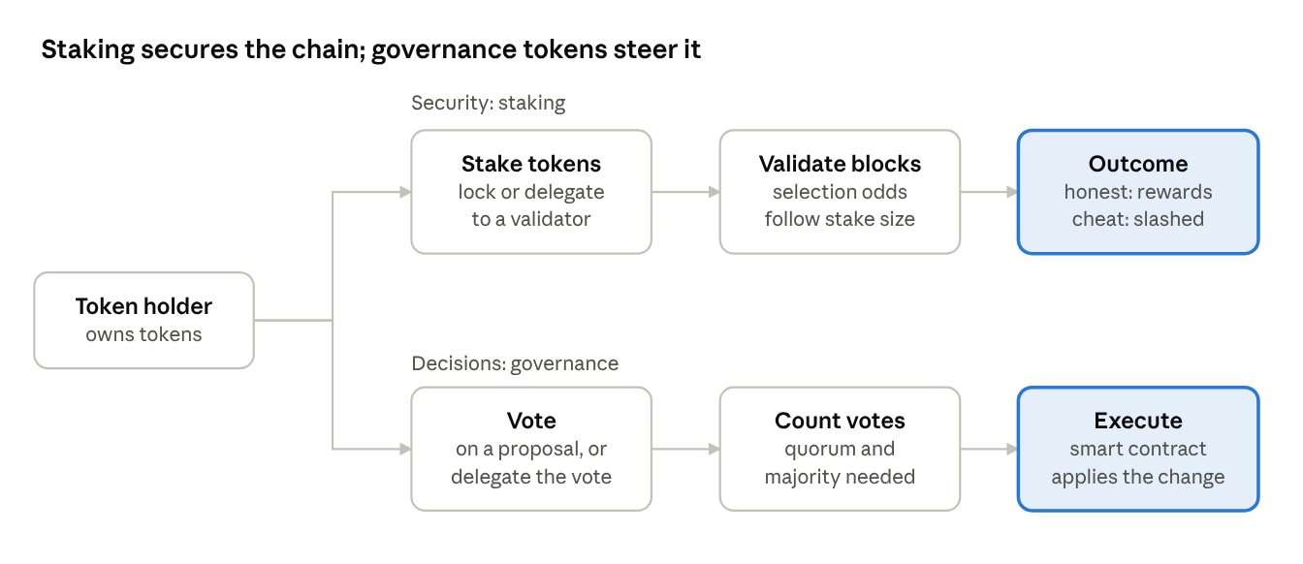
staking and governance paths · 2 lanes
The same token holder can take both paths: stake to protect the chain and earn or lose rewards, and vote to change its rules.

1. Key concepts
- Staking: locking tokens in the protocol, either by running a validator or by delegating to one, to take part in block production and validation. Honest work earns rewards; provable misbehaviour is penalised.
- Slashing: automatic destruction of part of a validator's stake for offences such as double-signing two conflicting blocks. Long downtime usually costs a smaller penalty.
- Governance token: a token that carries voting rights over protocol parameters, upgrades and the treasury. Examples: UNI (Uniswap), COMP (Compound), MKR (Maker).
- One token, two roles: some chains use the same token for both jobs. On Cosmos Hub and Polkadot, staked tokens secure the chain and also vote on proposals. On Ethereum, ETH secures the chain through staking, while protocol changes are agreed through the off-chain EIP process rather than token voting.

2. How staking secures the network
- Lock stake. A user locks tokens as a bond. Running an Ethereum validator needs 32 ETH; smaller holders delegate to a validator or join a staking pool.
- Selection. The protocol picks validators to propose and attest blocks, with the chance of selection tied to the size of the stake.
- Reward. Honest validators earn newly issued tokens plus transaction fees. Delegators share these rewards, minus the validator's commission.
- Penalty. If a validator double-signs or goes offline, the protocol slashes part of its stake, and delegators on that validator share the loss. Repeat or serious offenders are ejected.
- Attack cost. To attack the chain, an adversary must first buy a large share of the stake (in typical BFT-style proof of stake, roughly one third to stall finality and two thirds to control it) and would then lose much of it to slashing. Security therefore rests on economic cost, not on electricity as in proof of work.

3. How governance tokens drive decisions
- Proposal. Anyone meeting a minimum token deposit submits a proposal, such as changing a fee, adding a feature or spending treasury funds.
- Discussion. The community debates it on forums and social channels.
- Vote. Token holders vote yes, no or abstain, usually weighted one token, one vote. Holders who do not want to vote can delegate their voting power to a representative.
- Threshold. The proposal passes only if a quorum (minimum participation) and a majority threshold are met.
- Execution. Smart contracts execute the winning result automatically, often after a timelock that gives users time to exit if they disagree.

4. Illustrative example
The numbers below are assumptions made up for teaching, not data from a real network.
Step | Assumption | Result
Stake | Priya stakes 1,000 tokens through a validator | She joins the security of the chain and earns rewards at an assumed 5% a year, about 50 tokens
Honest year | Her validator signs correctly | She keeps her 1,000 tokens and the 50-token reward
Misbehaviour | Her validator double-signs and is slashed 5% | She loses about 50 tokens and the validator is ejected
Proposal | A proposal cuts the network fee by half | Voting opens for a fixed period
Vote | Priya's 1,000 staked tokens vote yes; quorum is 40% of staked supply | If turnout and majority are reached, the contract applies the change

5. Staking compared with governance tokens
Aspect | Staking | Governance token
Purpose | Secure the network and validate blocks | Decide protocol rules and treasury use
User action | Lock tokens, run or choose a validator | Vote or delegate votes on proposals
Reward | Block rewards and fees | Influence over the protocol; sometimes incentives for voting
Main risk | Slashing, lock-up period, validator failure | Whale domination, low turnout, vote buying
Examples | ETH, SOL, ADA, ATOM | UNI, COMP, MKR

6. Benefits and risks
- Benefits: incentives line up with the health of the network; far lower energy use than proof of work; decisions are open and executed by code; small holders can take part by delegating.
- Risks: wealth concentration lets large holders dominate votes (plutocracy); low turnout makes decisions easy to capture; large staking pools or liquid-staking providers can centralise power; locked tokens are illiquid. Mitigations include quadratic voting, delegation caps, quorum rules and timelocks.

7. Conclusion
Staking makes honesty profitable and attacks expensive, which protects the ledger, while governance tokens give the same stakeholders a transparent, rule-based way to change the protocol. Together they replace mining power and informal leadership with economic commitment and on-chain voting.

M5 Q4. Token standard for unique digital land parcels
Question: A startup is selling digital land parcels in a virtual estate platform, and each parcel is unique. Which token standard is most suitable?
Answer: ERC-721, the non-fungible token (NFT) standard on Ethereum, is the most suitable choice, because every parcel is one distinct, indivisible asset with its own owner.

1. Why ERC-721 fits
- Unique identity: each parcel is minted with its own tokenId, so no two tokens are interchangeable. Parcel #1042 can never be confused with parcel #1043.
- Clear single ownership: ownerOf(tokenId) returns exactly one owner, which matches one buyer holding one plot.
- Rich metadata: tokenURI(tokenId) points to a record holding the parcel's coordinates, size, location type and image, so each plot can have different properties and value.
- Safe transfer and trading: transferFrom, safeTransferFrom, approve and setApprovalForAll let owners sell, gift or list parcels on marketplaces without the startup's involvement.
- Provable provenance: every sale is recorded on chain, so buyers can verify the full ownership history and scarcity of a parcel.
- Wide ecosystem support: wallets, marketplaces and explorers already understand ERC-721, and major virtual-land platforms such as Decentraland and The Sandbox use it for their LAND parcels.

2. Comparison with other standards
Standard | Token type | Suitable for unique land? | Reason
ERC-20 | Fungible | No | Every token is identical and divisible, so it cannot represent one specific plot
ERC-721 | Non-fungible | Yes, best fit | One tokenId per parcel, single owner, per-token metadata, universal NFT support
ERC-1155 | Multi-token (fungible, non-fungible, semi-fungible) | Possible, but not the first choice | Can hold unique items and supports batch transfers, but adds complexity that a pure land registry does not need

3. Practical note
If the platform later also sells identical items such as common furniture or building materials, ERC-1155 is a good second contract for those items. The land parcels themselves should stay as ERC-721 tokens. On non-Ethereum chains, the equivalent is that chain's own NFT standard.

4. Conclusion
Because each parcel is unique, indivisible and individually owned, ERC-721 is the most suitable standard for the startup's virtual land.

